TOPIC 1 : INTRODUCTION

1.Given an array of strings words, return the first palindromic string in the array. If
there is no such string, return an empty string "". A string is palindromic if it reads
the same forward and backward.
Aim
To write a C program to find the first palindromic string in an array of strings. If no palindrome exists, return an empty string ("").
Algorithm
- Start.
- Read the number of strings n.
- Read all the strings into an array.
- Traverse each string in the array.
- For each string:
  - Compare the characters from the beginning and end.
  - If all corresponding characters match, the string is a palindrome.
- Print the first palindrome found and terminate.
- If no palindrome is found after checking all strings, print an empty string ("").
- Stop.
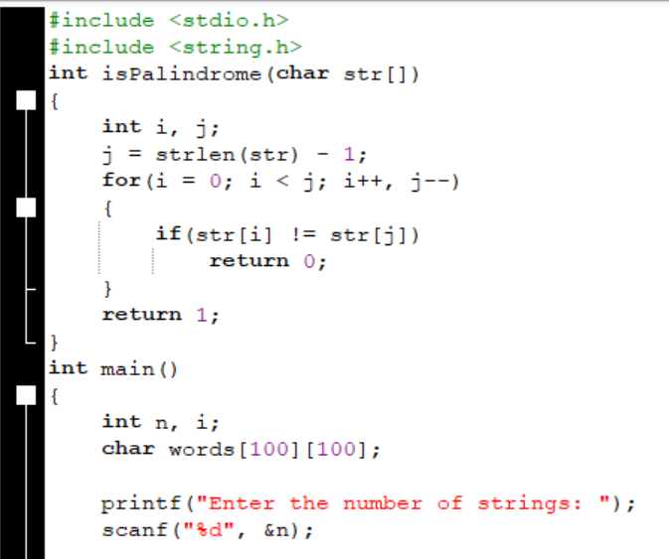
Code

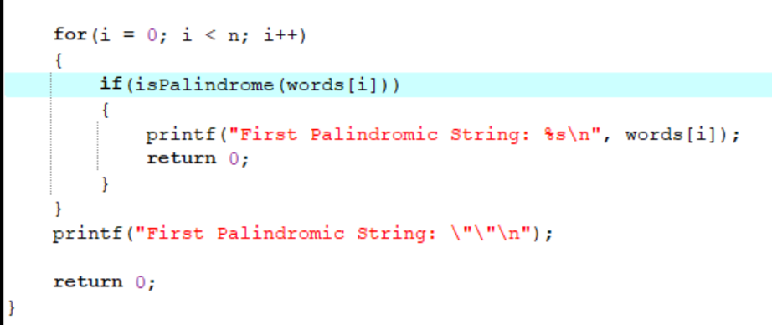
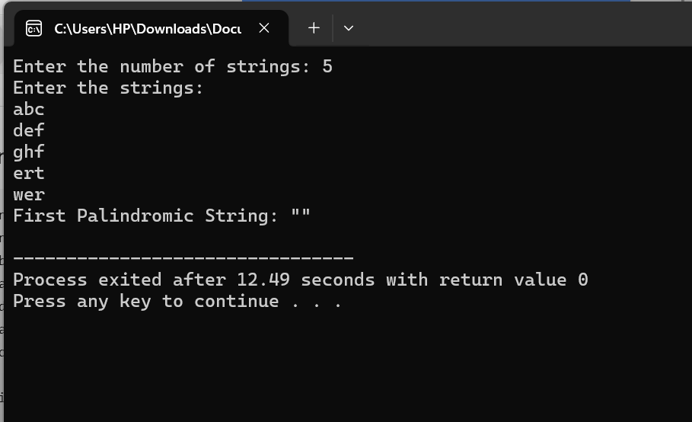
Output:

Time Complexity
- Let:
  - n = Number of strings
  - m = Maximum length of a string
- The isPalindrome() function checks one string in O(m) time.
- In the worst case, all n strings are checked.
Overall Time Complexity: O(n × m)
pace Complexity
- The palindrome checking function uses only a few variables (i and j).
Auxiliary Space Complexity: O(1)
(If the input array storing the strings is considered, the total memory required is O(n × m).)

Result
Thus, the C program to find the first palindromic string in an array of strings was implemented successfully, and the first palindrome was displayed. If no palindrome exists, an empty string ("") is printed.

2.You are given two integer arrays nums1 and nums2 of sizes n and m, respectively.
Calculate the following values: answer1 : the number of indices i such that nums1[i]
exists in nums2. answer2 : the number of indices i such that nums2[i] exists in
nums1 Return [answer1,answer2].

Aim
To write a C program to find:
- answer1: The number of elements in nums1 that are present in nums2.
- answer2: The number of elements in nums2 that are present in nums1.
Finally, display the result as [answer1, answer2].
Algorithm
- Start.
- Read the size of the first array n.
- Read the elements of nums1.
- Read the size of the second array m.
- Read the elements of nums2.
- Initialize answer1 and answer2 to 0.
- For each element in nums1:
  - Check whether it exists in nums2.
  - If found, increment answer1.
- For each element in nums2:
  - Check whether it exists in nums1.
  - If found, increment answer2.
- Print the result as [answer1, answer2].
- Stop.

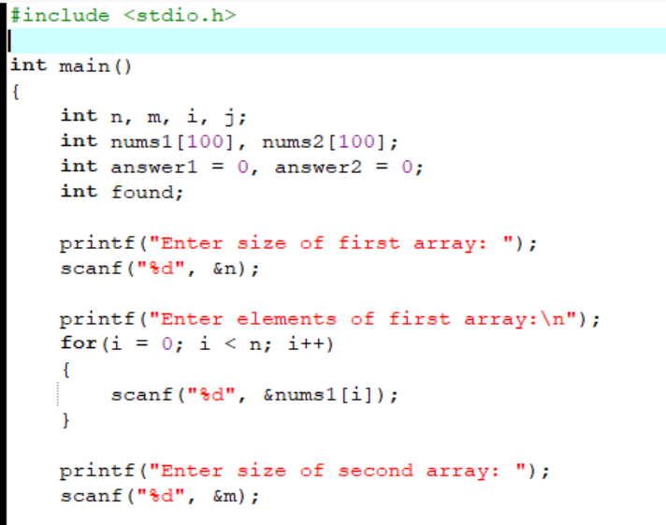
Code
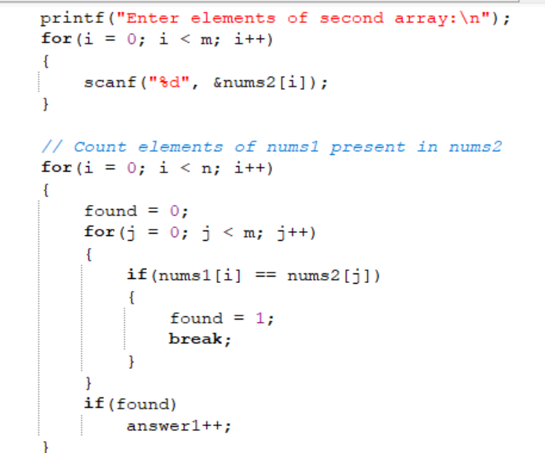
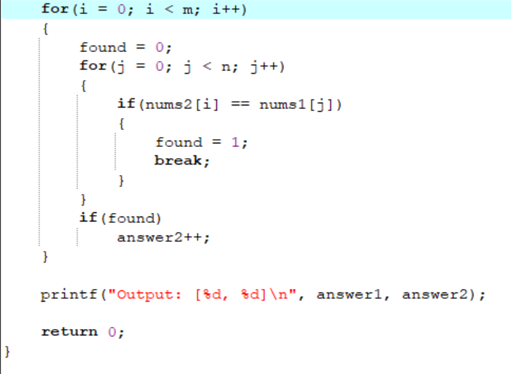

Output
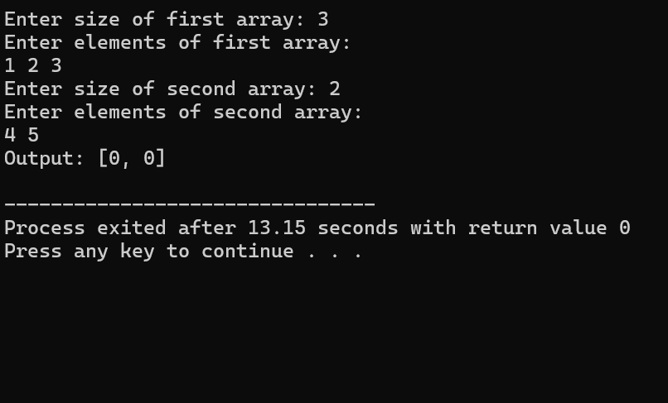

Time Complexity
- Best Case: O(m)
(When the first string itself is a palindrome.)
- Worst Case: O(n × m)
(When all n strings are checked, and each string has a maximum length of m.)
Where:
- n = Number of strings
- m = Maximum length of a string
Space Complexity
- Auxiliary Space Complexity: O(1)
Only a few extra variables (left, right, and i) are used.

Result
Thus, the C program to find the first palindromic string in an array of strings was successfully implemented and executed. The program correctly displays the first palindrome if it exists; otherwise, it displays an empty string ("").

3.You are given a 0-indexed integer array nums. The distinct count of a subarray of nums is defined as: Let nums[i..j] be a subarray of nums consisting of all the indices from i to j such that 0 <= i <= j < nums.length. Then the number of distinct values in nums[i..j] is called the distinct count of nums[i..j]. Return the sum of the squares of distinct counts of all subarrays of nums. A subarray is a contiguous non-empty sequence of elements within an array.
Aim: To write a C program to find the sum of the squares of the distinct counts of all possible subarrays of a given integer array.
Algorithm
- Start.
- Read the size of the array n.
- Read the array elements.
- Initialize sum = 0.
- For every starting index i:
  - Create an empty array (or visited array) to keep track of distinct elements.
  - Initialize distinct = 0.
- For every ending index j from i to n-1:
  - Check whether nums[j] has already appeared in the current subarray.
  - If it is a new element:
    - Increase distinct by 1.
  - Add (distinct × distinct) to sum.
- Repeat until all subarrays are processed.
- Print the final value of sum.
- Stop.

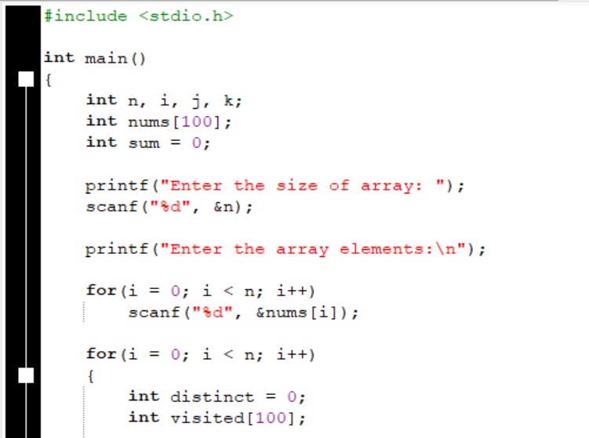
Source code:
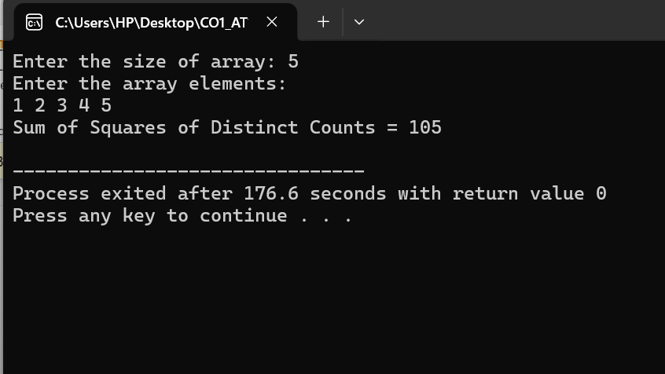
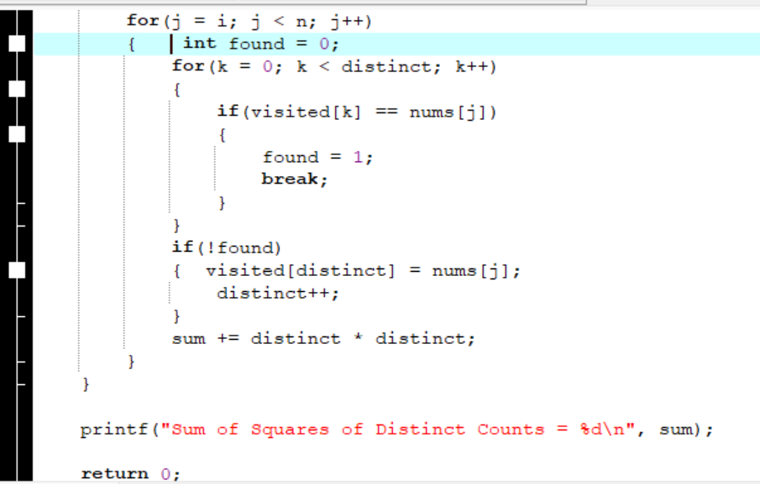

Time Complexity
- There are O(n²) subarrays.
- For each subarray, checking whether an element is already present may take O(n) time.
Worst Case Time Complexity$\boxed{O(n^{3})}$
Best Case Time Complexity$\boxed{O(n^{3})}$
Space Complexity
The program uses an additional visited array of size n.
Auxiliary Space Complexity$\boxed{O(n)}$
Result
Thus, the C program to calculate the sum of the squares of the distinct counts of all possible subarrays was successfully implemented and executed. The program correctly computes the required sum by considering every contiguous subarray and counting its distinct elements.

4. Given a 0-indexed integer array nums of length n and an integer k, return the number of pairs (i, j) where 0 <= i < j < n, such that nums[i] == nums[j] and (i *j) is divisible by k.
Aim
To write a C program to count the number of pairs (i, j) in an array such that:
- 0 ≤ i < j < n
- nums[i] == nums[j]
- (i × j) is divisible by k

Algorithm
- Start.
- Read the size of the array n.
- Read the array elements.
- Read the value of k.
- Initialize count = 0.
- Traverse the array using two nested loops:
  - Outer loop from i = 0 to n-2.
  - Inner loop from j = i+1 to n-1.
- For every pair:
  - Check whether nums[i] == nums[j].
  - Check whether (i × j) % k == 0.
  - If both conditions are true, increment count.
- Print count.
- Stop.

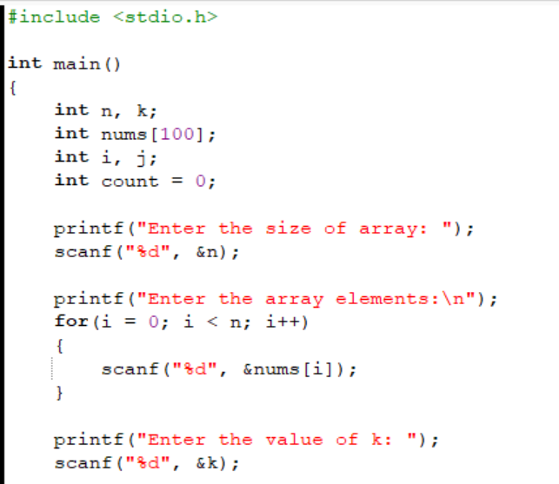
Source code:
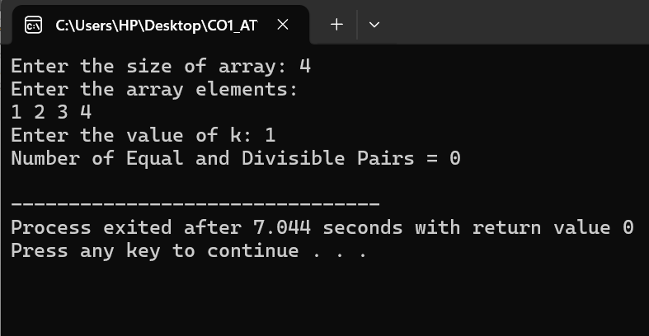
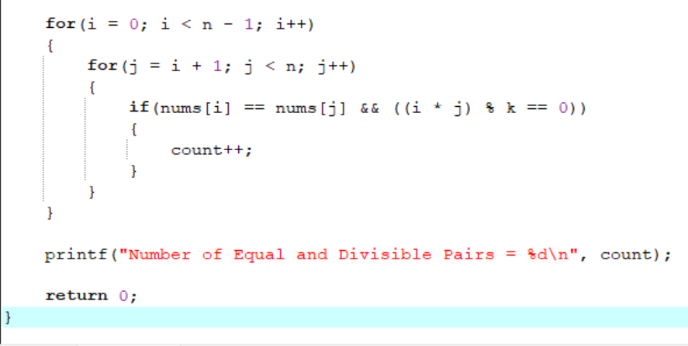

Output

Time Complexity
The algorithm uses two nested loops to examine every possible pair of indices.
- Best Case: O(n²)
- Worst Case: O(n²)
where n is the number of elements in the array.

Space Complexity
The program uses only a few extra variables (i, j, count, k).
- Auxiliary Space Complexity: O(1)

Result
Thus, the C program to count the number of equal and divisible pairs in an array was successfully implemented and executed. The program correctly identifies all pairs that satisfy both the equality condition (nums[i] == nums[j]) and the divisibility condition ((i × j) is divisible by k).

5.Write a program FOR THE BELOW TEST CASES with least time complexity
Test Cases: -
Input: {1, 2, 3, 4, 5} Expected Output: 5
Input: {7, 7, 7, 7, 7} Expected Output: 7
Input: {-10, 2, 3, -4, 5} Expected Output: 5
Aim
To write a C program to find the maximum element in an array using the least possible time complexity.

Algorithm
- Start.
- Read the size of the array n.
- Read the array elements.
- Assume the first element is the maximum.
- Traverse the array from the second element to the last.
- If the current element is greater than the maximum, update the maximum.
- After traversing the entire array, print the maximum element.
- Stop.
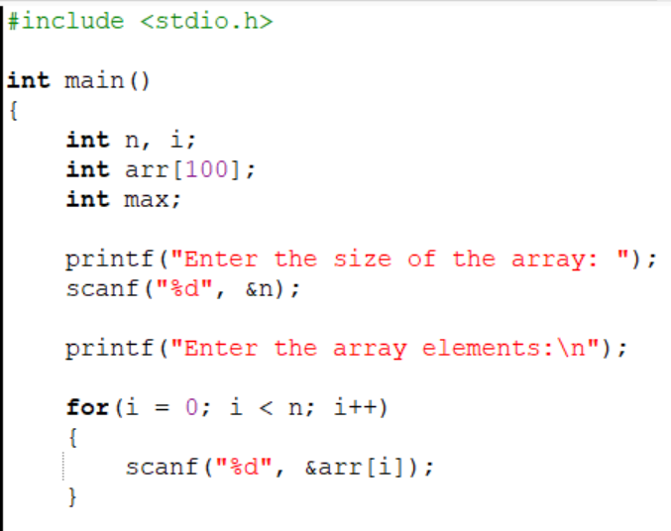
Source code:
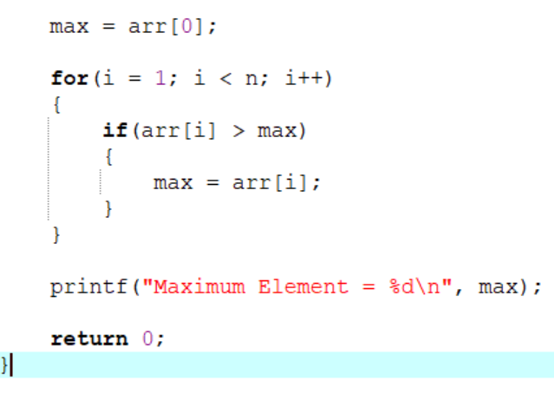

Output:
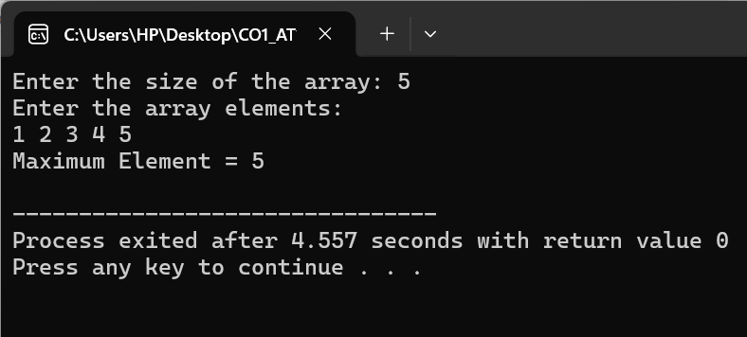

Time Complexity
- Best Case: O(n)
- Worst Case: O(n)
The algorithm scans the array only once.

Space Complexity
- Auxiliary Space Complexity: O(1)

Result
Thus, the C program to find the maximum element in an array using the least possible time complexity was successfully implemented and executed. The program correctly identifies the largest element in a single traversal of the array.

6. You have an algorithm that process a list of numbers. It firsts sorts the list
using an efficient sorting algorithm and then finds the maximum element in
sorted list. Write the code for the same.
Aim
To write a C program that first sorts a list of numbers using an efficient sorting algorithm and then finds the maximum element in the sorted list.
Algorithm
- Start.
- Read the size of the array n.
- If n == 0, print "List is empty." and stop.
- Read the array elements.
- Sort the array using the Quick Sort algorithm.
- Since the array is sorted in ascending order, the last element is the maximum.
- Print the sorted array.
- Print the maximum element.
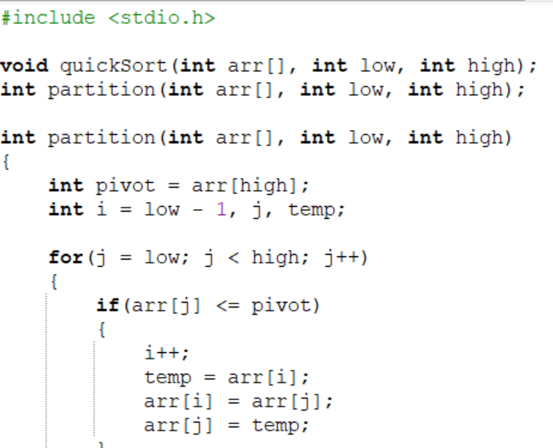
- Stop.
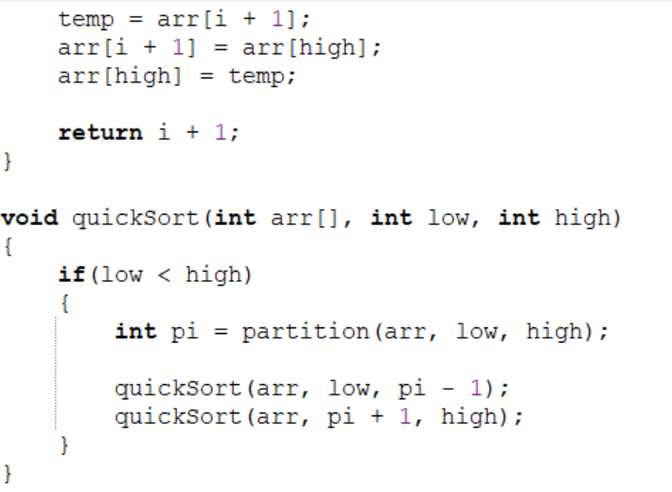
Source code:
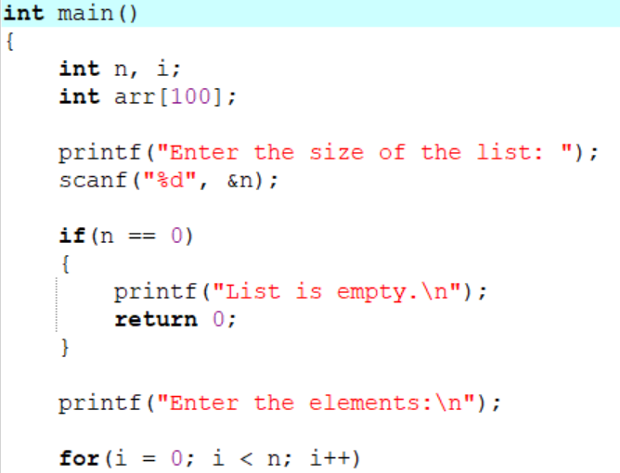

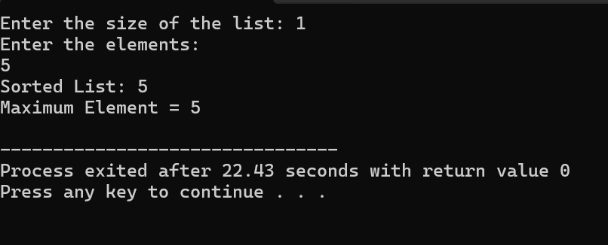
Output

Time Complexity
- Best/Average Case: O(n log n)
- Worst Case: O(n²)

Space Complexity
- Auxiliary Space: O(log n) (due to recursion in Quick Sort)
- Worst Case: O(n) (recursion stack)

Result
Thus, the C program to sort a list using Quick Sort and find the maximum element was successfully implemented and executed. The program correctly handles empty lists, single-element lists, and lists with duplicate elements while displaying the sorted list and the maximum element.

7. Write a program that takes an input list of n numbers and creates a new list
containing only the unique elements from the original list. What is the space
complexity of the algorithm?
Test Cases
Some Duplicate Elements
Input: [3, 7, 3, 5, 2, 5, 9, 2]
Expected Output: [3, 7, 5, 2, 9] (Order may vary based on the algorithm
used)
Negative and Positive Numbers
Input: [-1, 2, -1, 3, 2, -2]
Expected Output: [-1, 2, 3, -2] (Order may vary)
List with Large Numbers
Input: [1000000, 999999, 1000000]
Expected Output: [1000000, 999999]

Aim
To write a C program that accepts a list of n numbers and creates a new list containing only the unique elements from the original list.

Algorithm
- Start.
- Read the number of elements n.
- Read the elements into an array.
- Create another array to store unique elements.
- Initialize the count of unique elements to 0.
- For each element in the original array:
  - Check whether it already exists in the unique array.
  - If it does not exist, add it to the unique array.
- Display the unique elements.
- Stop.
Code:
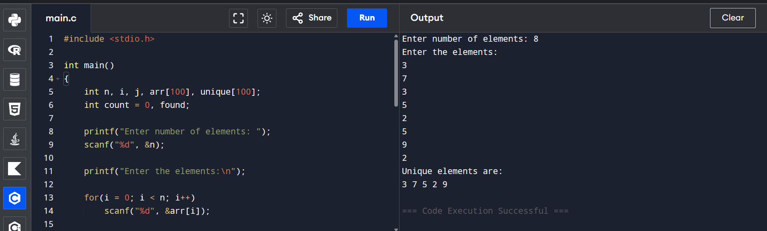
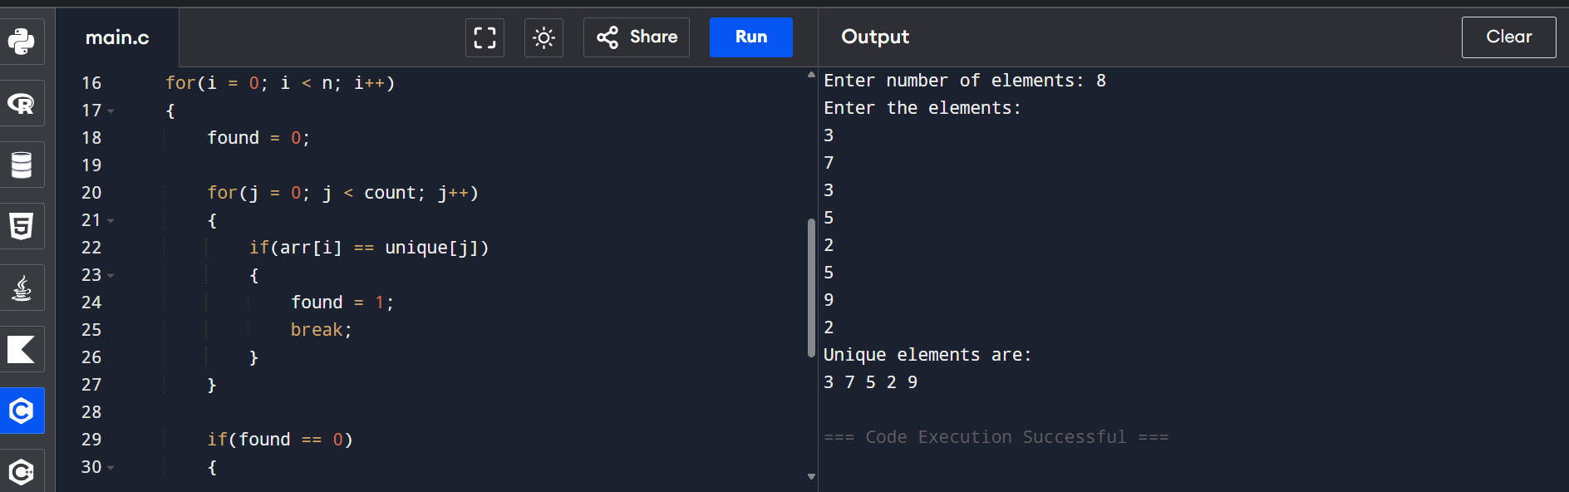
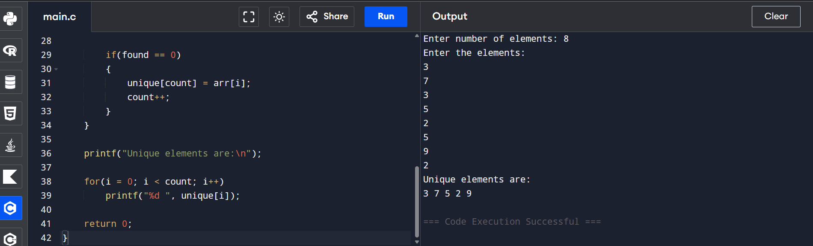
Sample Input
Enter number of elements: 8
Enter the elements:
3
7
3
5
2
5
9
2
Output
Unique elements are:
3 7 5 2 9
Time Complexity
- The outer loop runs n times.
- For each element, the inner loop may compare with all previously stored unique elements.
Time Complexity: O(n²)

Space Complexity
- Original array stores n elements.
- Unique array stores at most n elements.
Auxiliary Space Complexity: O(n)

Result
The program was successfully executed. It reads a list of numbers and creates a new list containing only the unique elements while preserving their first occurrence. The algorithm has a time complexity of O(n²) and a space complexity of O(n).

8.Sort an array of integers using the bubble sort technique. Analyze its time complexity using Big-O notation. Write the code
Aim
To write a C program to sort an array of integers using the Bubble Sort technique and analyze its time complexity using Big-O notation.

Algorithm
- Start.
- Read the number of elements n.
- Read the array elements.
- Compare each pair of adjacent elements.
- If the left element is greater than the right element, swap them.
- Repeat the process for all elements until the array is sorted.
- Display the sorted array.
- Stop.
Code:
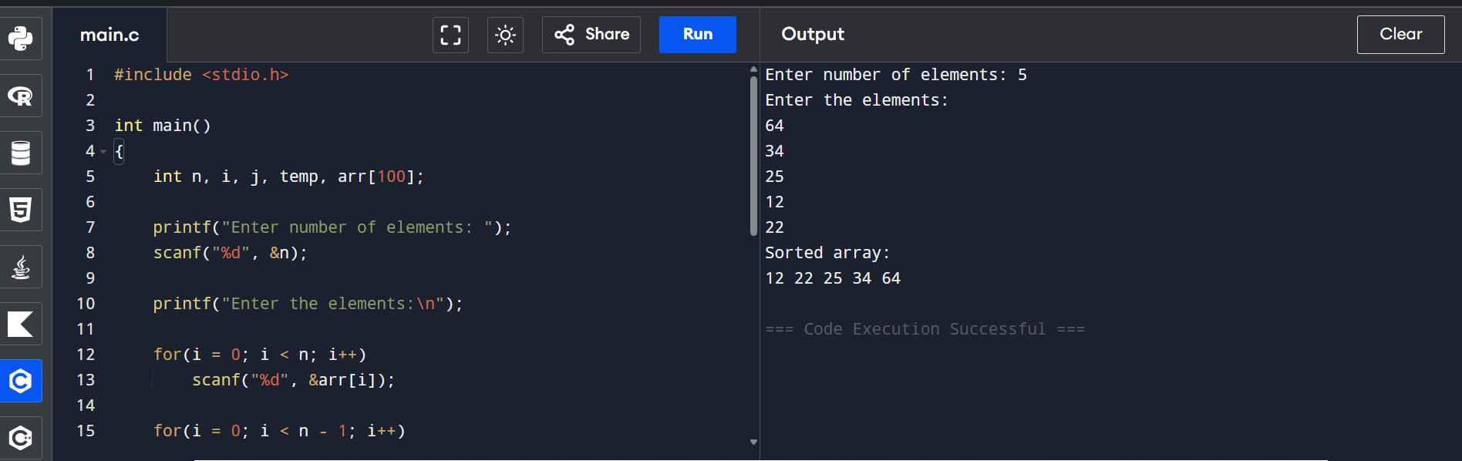
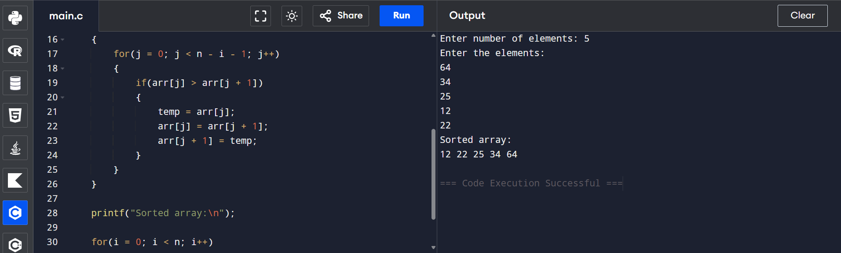
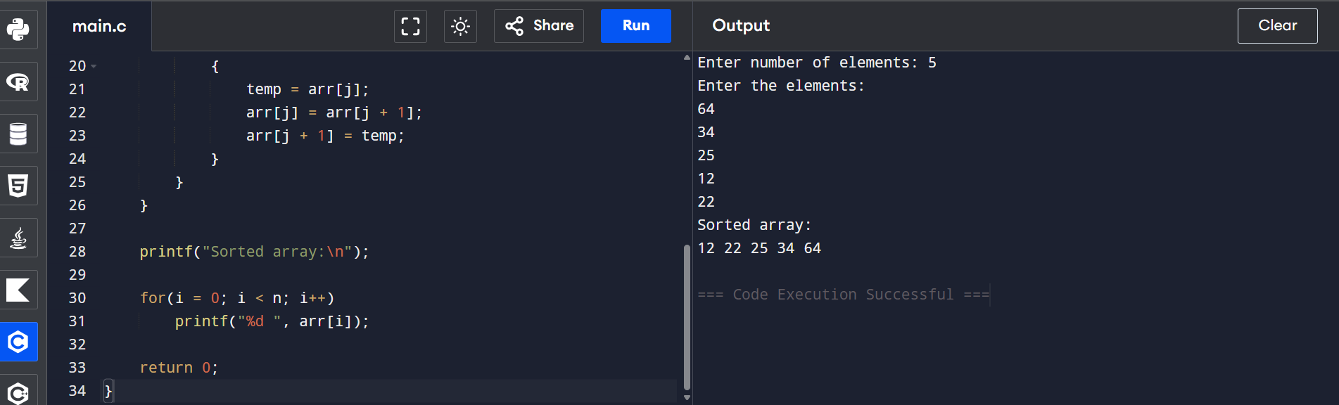Sample Input
Enter number of elements: 5
Enter the elements:
64
34
25
12
22
Output
Sorted array:
12 22 25 34 64
Time Complexity (Big-O)
- Best Case: O(n²) (without optimization)
- Average Case: O(n²)
- Worst Case: O(n²)
Bubble Sort repeatedly compares adjacent elements, so the number of comparisons is approximately n × (n − 1) / 2, which gives O(n²) time complexity.

Space Complexity
- Uses only one temporary variable for swapping.
Space Complexity: O(1)

Result
The program was successfully executed to sort the given array using the Bubble Sort algorithm. The array was sorted in ascending order. The algorithm has a time complexity of O(n²) and a space complexity of O(1).

9.Checks if a given number x exists in a sorted array arr using binary search.
Analyze its time complexity using Big-O notation.
Test Case:
Example X={ 3,4,6,-9,10,8,9,30} KEY=10
Output: Element 10 is found at position 5
Aim
To write a C program to check whether a given number (key) exists in a sorted array using the Binary Search algorithm and analyze its time complexity using Big-O notation.
Algorithm
- Start.
- Read the number of elements n.
- Read the sorted array elements.
- Read the search key.
- Set low = 0 and high = n - 1.
- Repeat while low <= high:
  - Find the middle element mid = (low + high) / 2.
  - If arr[mid] == key, display its position and stop.
  - If key < arr[mid], set high = mid - 1.
  - Otherwise, set low = mid + 1.
- If the key is not found, display "Element not found."
- Stop.
Code:
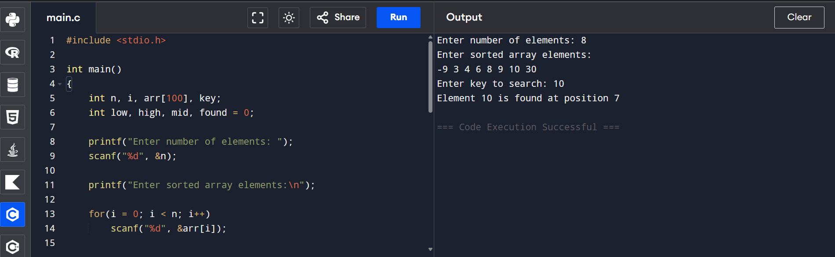
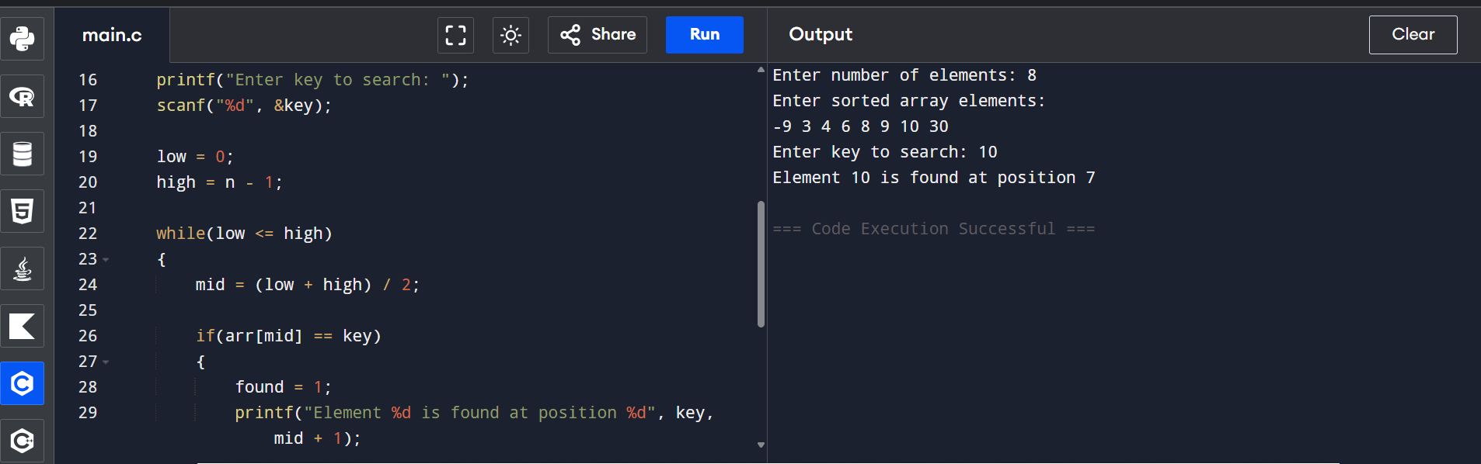
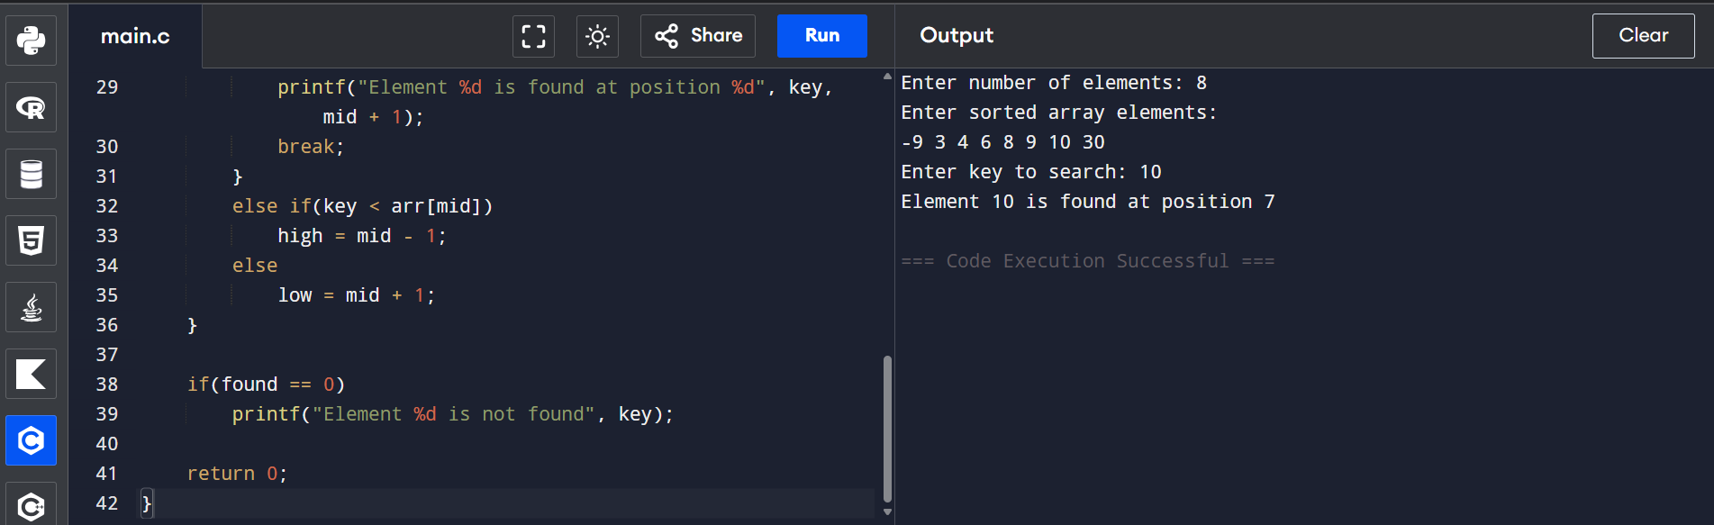
Sample Input
Enter number of elements: 8
Enter sorted array elements:
-9 3 4 6 8 9 10 30
Enter key to search: 10
Output
Element 10 is found at position 7
Time Complexity (Big-O)
- Best Case: O(1) (key found at the middle element)
- Average Case: O(log n)
- Worst Case: O(log n)
The search space is reduced to half in each iteration, giving a time complexity of O(log n).

Space Complexity
- Only a few extra variables (low, high, mid, found) are used.
Space Complexity: O(1)

Result
The program was successfully executed to search for an element using the Binary Search algorithm. It correctly displayed whether the given key was present in the sorted array. The algorithm has a time complexity of O(log n) and a space complexity of O(1).

10.Given an array of integers nums, sort the array in ascending order and return
it. You must solve the problem without using any built-in functions in
O(nlog(n)) time complexity and with the smallest space complexity possible.
Aim
To write a C program to sort an array of integers in ascending order using the Merge Sort algorithm without using any built-in sorting functions, and analyze its time complexity using Big-O notation.

Algorithm
- Start.
- Read the number of elements n.
- Read the array elements.
- Divide the array into two halves recursively until each subarray contains one element.
- Merge the subarrays by comparing elements and arranging them in ascending order.
- Repeat the merging process until the complete array is sorted.
- Display the sorted array.
- Stop.
Code:
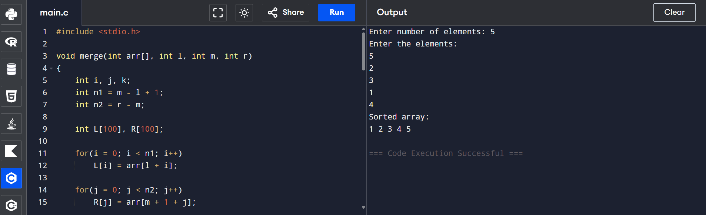
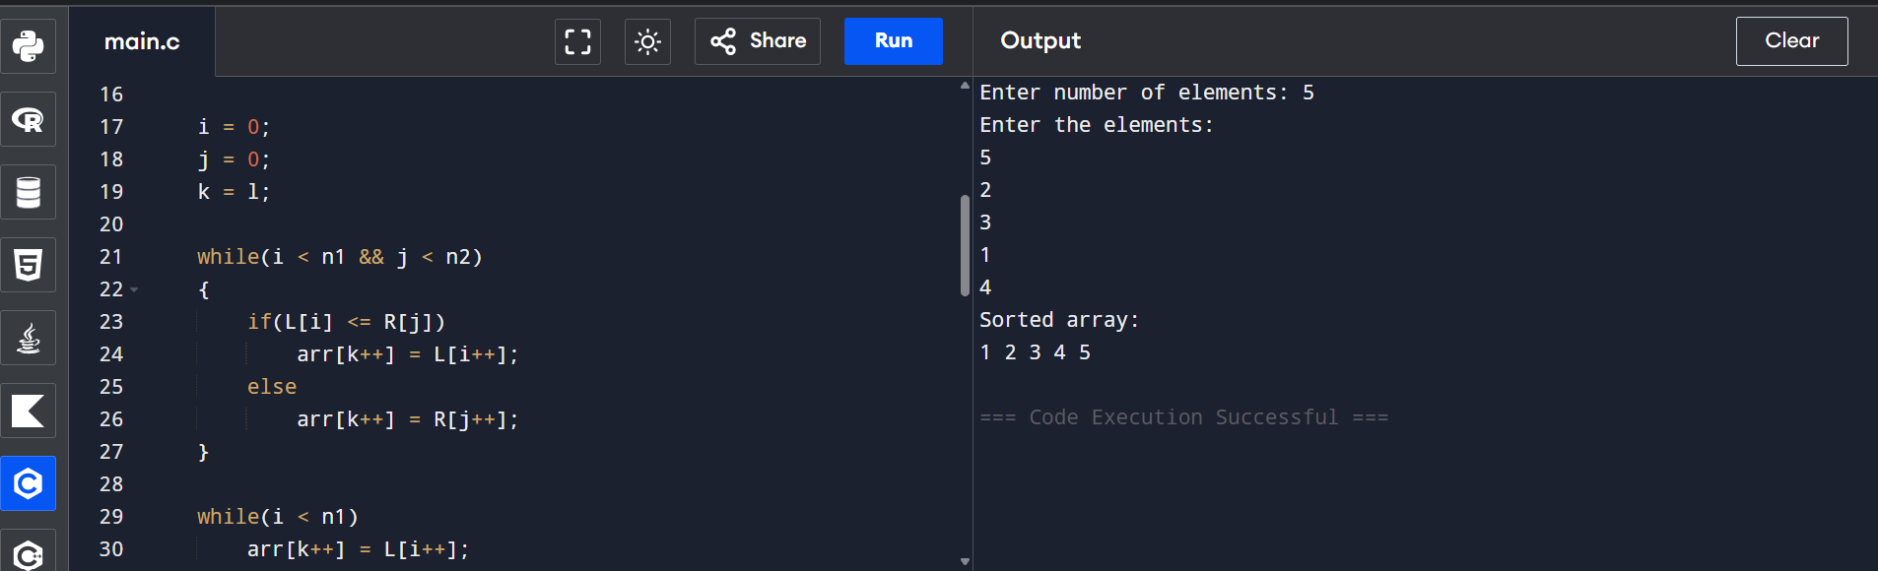
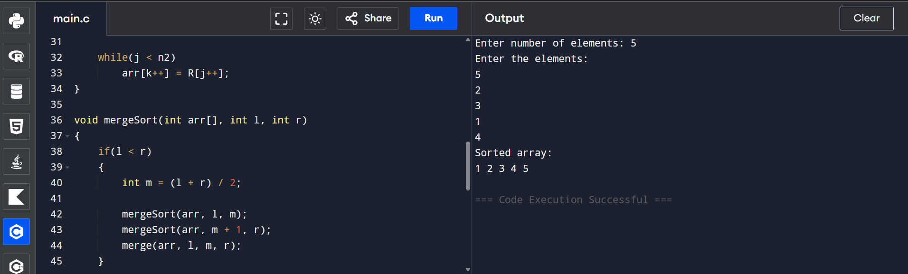
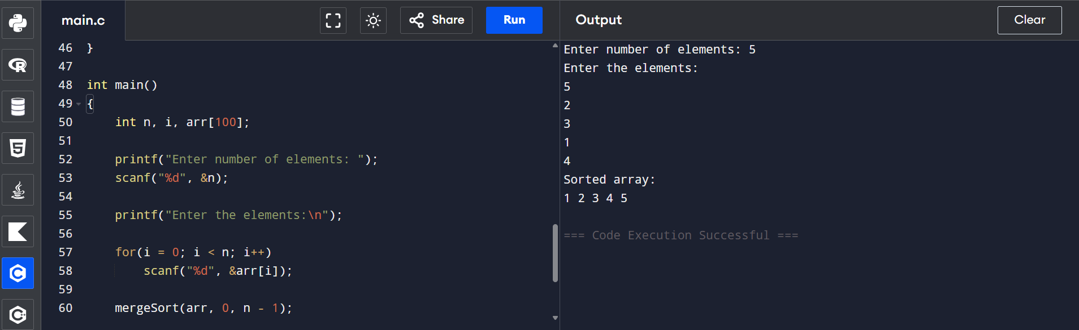
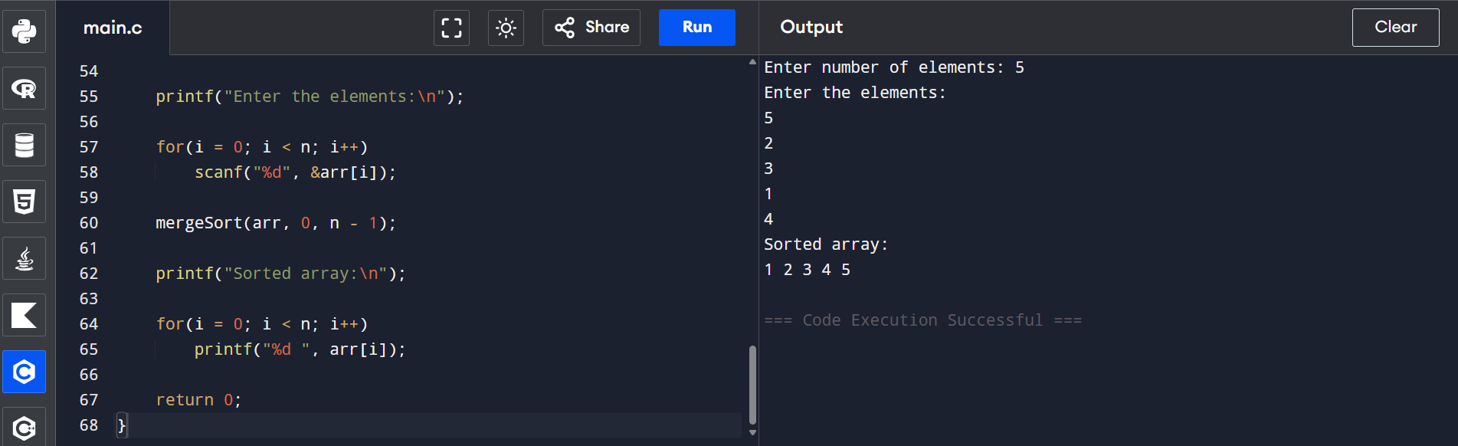
Sample Input
Enter number of elements: 5
Enter the elements:
5
2
3
1
4
Output
Sorted array:
1 2 3 4 5
Time Complexity (Big-O)
- Best Case: O(n log n)
- Average Case: O(n log n)
- Worst Case: O(n log n)
Merge Sort divides the array into halves and merges them efficiently, resulting in O(n log n) time complexity.

Space Complexity
- Merge Sort uses temporary arrays during the merge process.
Space Complexity: O(n)

Result
The program was successfully executed to sort the given array in ascending order using the Merge Sort algorithm without using any built-in sorting functions. The algorithm achieves a time complexity of O(n log n) and a space complexity of O(n).

11. Given an m x n grid and a ball at a starting cell, find the number of ways to
move the ball out of the grid boundary in exactly N steps.
Example:
· Input: m=2,n=2,N=2,i=0,j=0 · Output: 6

Aim
To write a C program to find the number of ways to move a ball out of an m × n grid boundary in exactly N steps, starting from a given cell, and analyze its time and space complexity.

Algorithm
- Start.
- Read the values of m, n, N, starting row (i), and starting column (j).
- Define a recursive function:
  - If the ball moves outside the grid exactly after all steps are used, return 1.
  - If the ball is inside the grid and no steps remain, return 0.
- From the current cell, recursively move the ball in four directions:
  - Up
  - Down
  - Left
  - Right
- Add the number of valid paths from all four directions.
- Display the total number of ways.
- Stop.
Code:
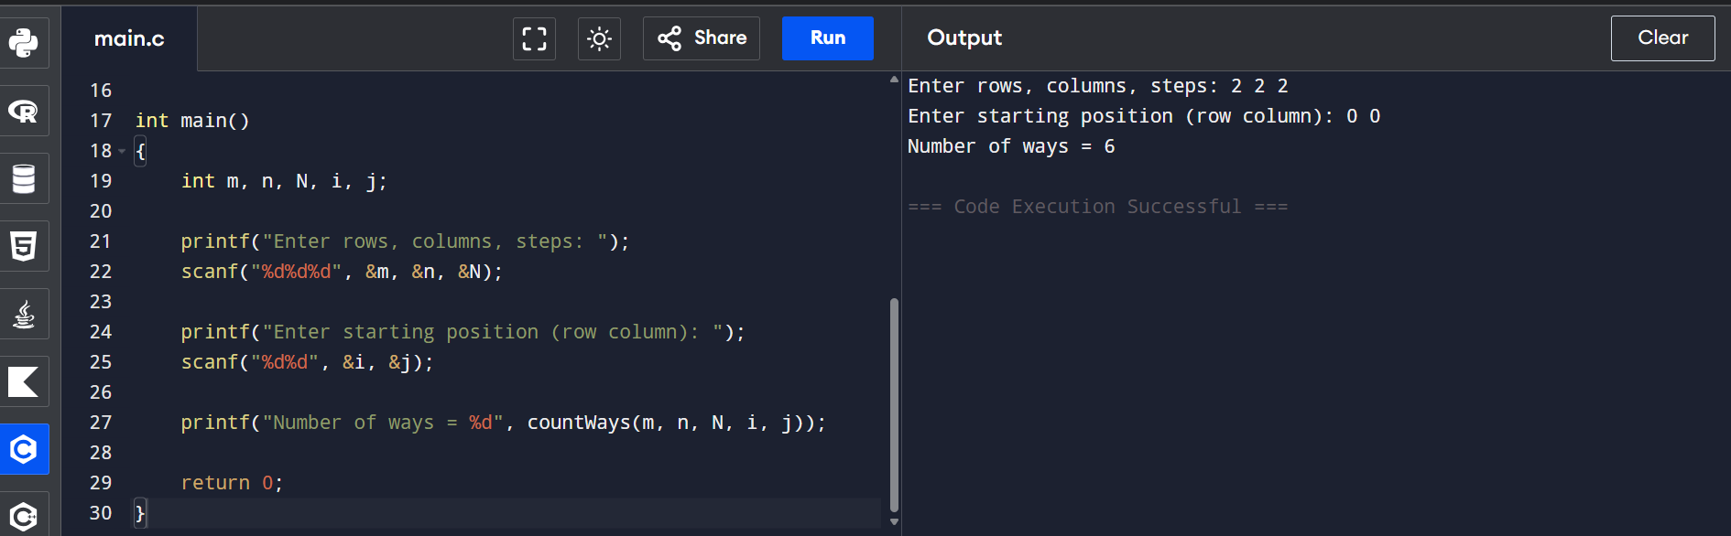
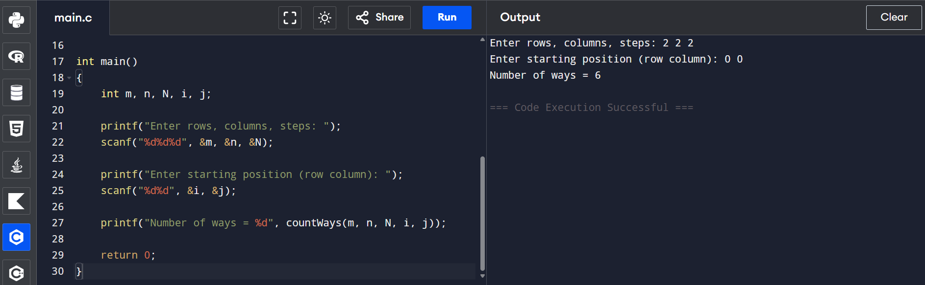
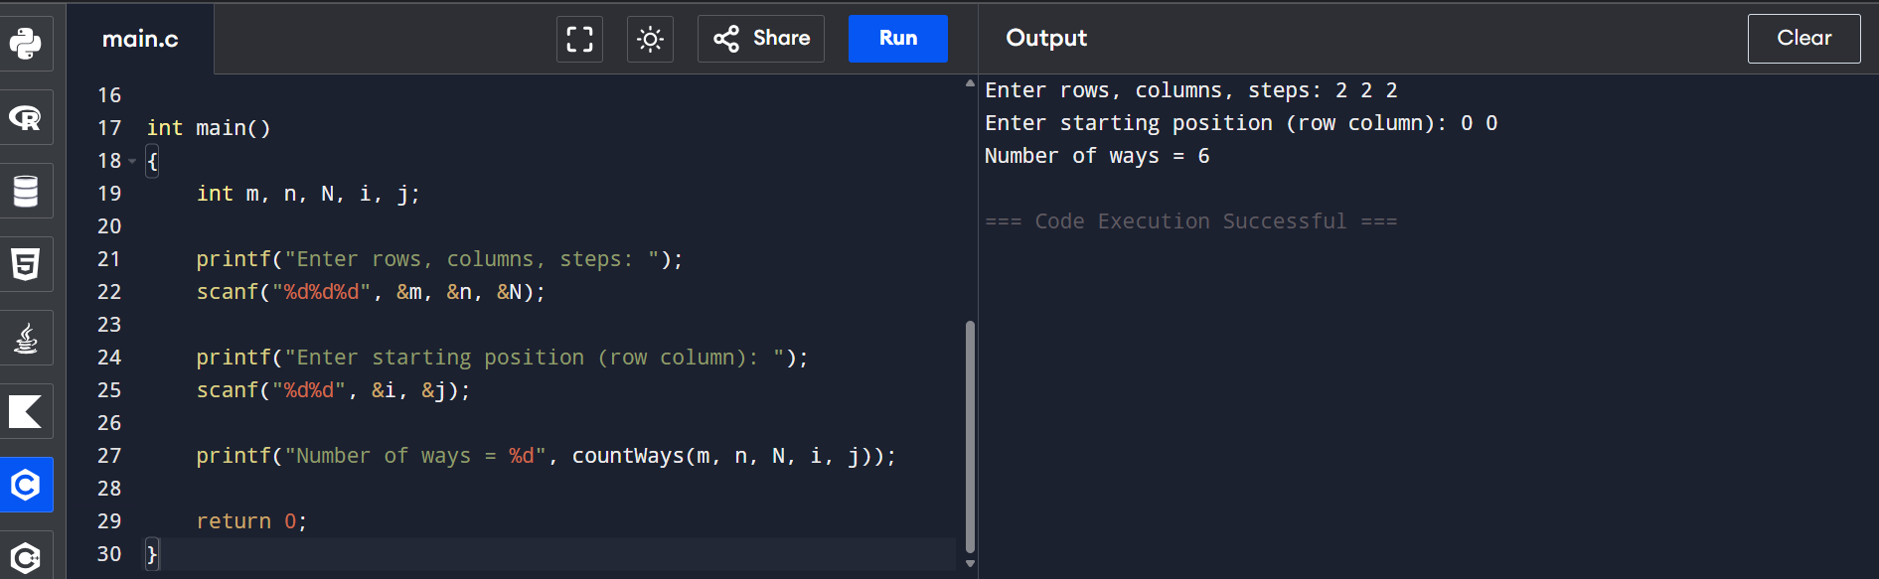
Sample Input
Enter rows, columns, steps: 2 2 2
Enter starting position (row column): 0 0
Output
Number of ways = 6
Time Complexity (Big-O)
- At each step, the ball can move in 4 directions.
- Maximum recursive calls = 4ᴺ.
Time Complexity: O(4ᴺ)

Space Complexity
- The recursion depth is at most N.
Space Complexity: O(N)

Result
The program was successfully executed to find the number of ways a ball can move outside the grid boundary in exactly N steps. The recursive algorithm correctly computes all possible paths. It has a time complexity of O(4ᴺ) and a space complexity of O(N).

12. You are a professional robber planning to rob houses along a street. Each house has a certain amount of money stashed. All houses at this place are arranged in a circle. That means the first house is the neighbor of the last one. Meanwhile, adjacent houses have security systems connected, and it will automatically contact the police if two adjacent houses were broke into on the same night.
Examples:
Input : nums = [2, 3, 2]
Output : The maximum money you can rob without alerting the
police is 3(robbing house 1).
(ii)Input : nums = [1, 2, 3, 1]
Output : The maximum money you can rob without alerting the
police is 4 (robbing house 1 and house 3).

Aim
To write a C program to find the maximum amount of money that can be robbed from circularly arranged houses without robbing two adjacent houses.

Algorithm
- Read the number of houses n.
- Read the money present in each house.
- If there is only one house, print its value.
- Otherwise,
  - Calculate the maximum robbery from house 0 to n-2.
  - Calculate the maximum robbery from house 1 to n-1.
- Print the maximum of the two values.
Code:
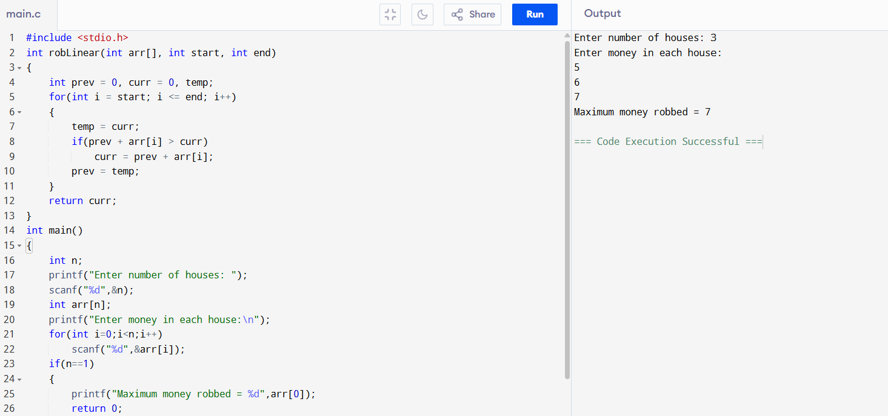
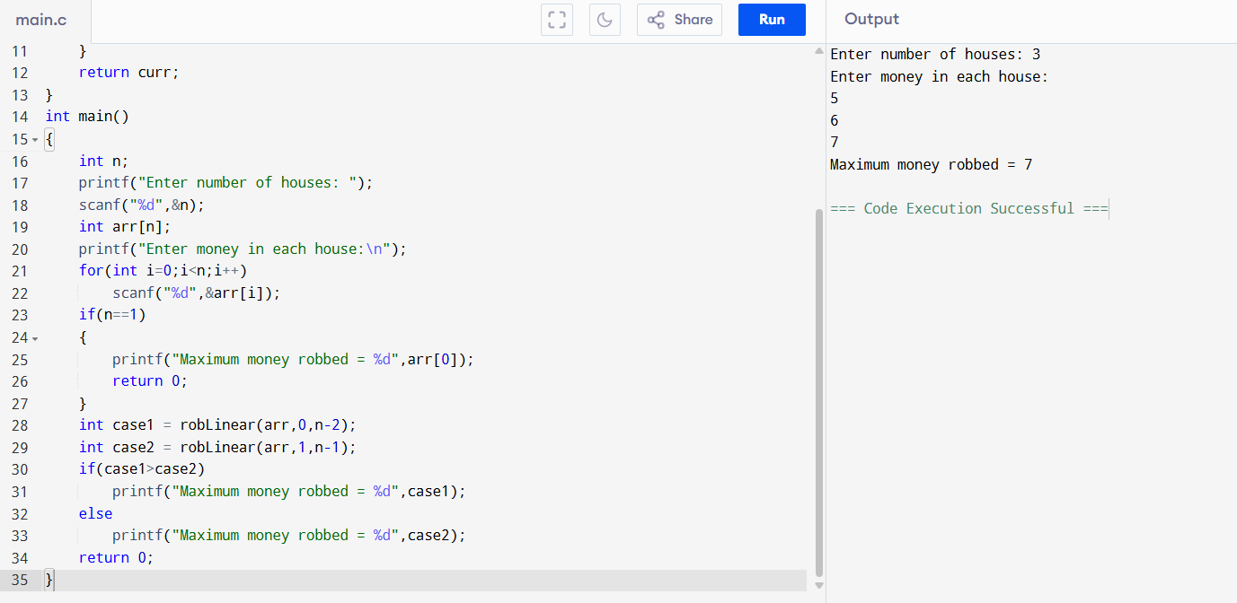
Sample Input
Enter number of houses: 3
Enter money in each house:
2
3
2
Sample Output
Maximum money robbed = 3
Time Complexity
O(n)
Space Complexity
O(1)

Result
Thus, the C program to find the maximum amount of money that can be robbed from circularly arranged houses was executed successfully.

13. You are climbing a staircase. It takes n steps to reach the top. Each time you can either climb 1 or 2 steps. In how many distinct ways can you climb to the top?
Examples:
Input: n=4 Output: 5
Input: n=3 Output: 3
Aim
To write a C program to find the number of distinct ways to climb a staircase when one can climb either one or two steps at a time.

Algorithm
- Read the number of steps n.
- If n is 1 or 2, print n.
- Initialize two variables to store previous two values.
- Compute the number of ways iteratively.
- Print the final answer.
Code:
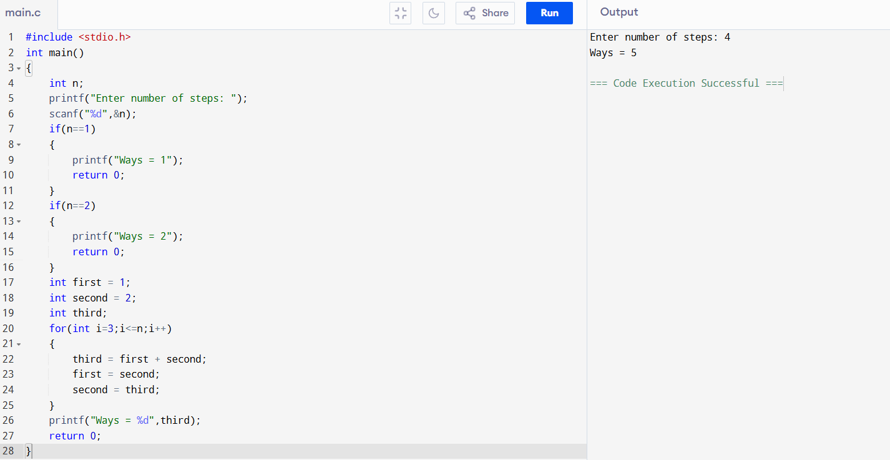
Sample Input
Enter number of steps: 4
Sample Output
Ways = 5
Time Complexity
O(n)
Space Complexity
O(1)

Result
Thus, the C program to calculate the number of distinct ways to climb the staircase was executed successfully.

14. A robot is located at the top-left corner of a m×n grid .The robot can only move either down or right at any point in time. The robot is trying to reach the bottom-right corner of the grid. How many possible unique paths are there?
Examples:
Input: m=7,n=3 Output: 28
Input: m=3,n=2 Output: 3
Aim
To write a C program to find the number of unique paths for a robot to travel from the top-left corner to the bottom-right corner of an m × n grid, moving only right or down.
Algorithm
- Read the values of m (rows) and n (columns).
- Create a 2D DP array.
- Initialize the first row and first column with 1.
- Fill the remaining cells using:
  - dp[i][j] = dp[i-1][j] + dp[i][j-1]
- Print dp[m-1][n-1].

Code:
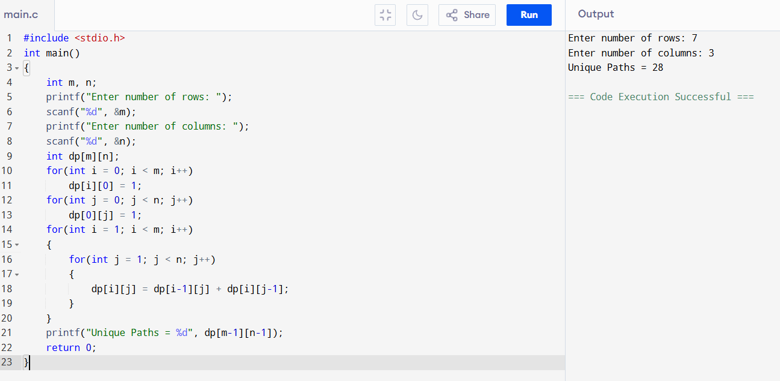

Sample Input
Enter number of rows: 7
Enter number of columns: 3
Sample Output
Unique Paths = 28
Time Complexity
O(m × n)
Space Complexity
O(m × n)
Result
Thus, the C program to find the number of unique paths in a grid was executed successfully.

15. In a string S of lowercase letters, these letters form consecutive groups of the same character. For example, a string like s = "abbxxxxzyy" has the groups "a", "bb", "xxxx", "z", and "yy". A group is identified by an interval [start, end], where start and end denote the start and end indices (inclusive) of the group. In the above example, "xxxx" has the interval [3,6]. A group is considered large if it has 3 or more characters. Return the intervals of every large group sorted in increasing order by start index.
Example 1:
Input: s = "abbxxxxzzy"
Output: [[3,6]]
Explanation: "xxxx" is the only large group with start index 3 and end index 6.
Example 2:
Input: s = "abc"
Output: []
Explanation: We have groups "a", "b", and "c", none of which are large
groups.

Aim
To write a C program to identify all large groups (three or more consecutive identical characters) in a string and print their start and end indices.
Algorithm
- Read the input string.
- Traverse the string from left to right.
- Count consecutive identical characters.
- If the count is greater than or equal to 3, print the start and end indices.
- Continue until the end of the string.

Code:
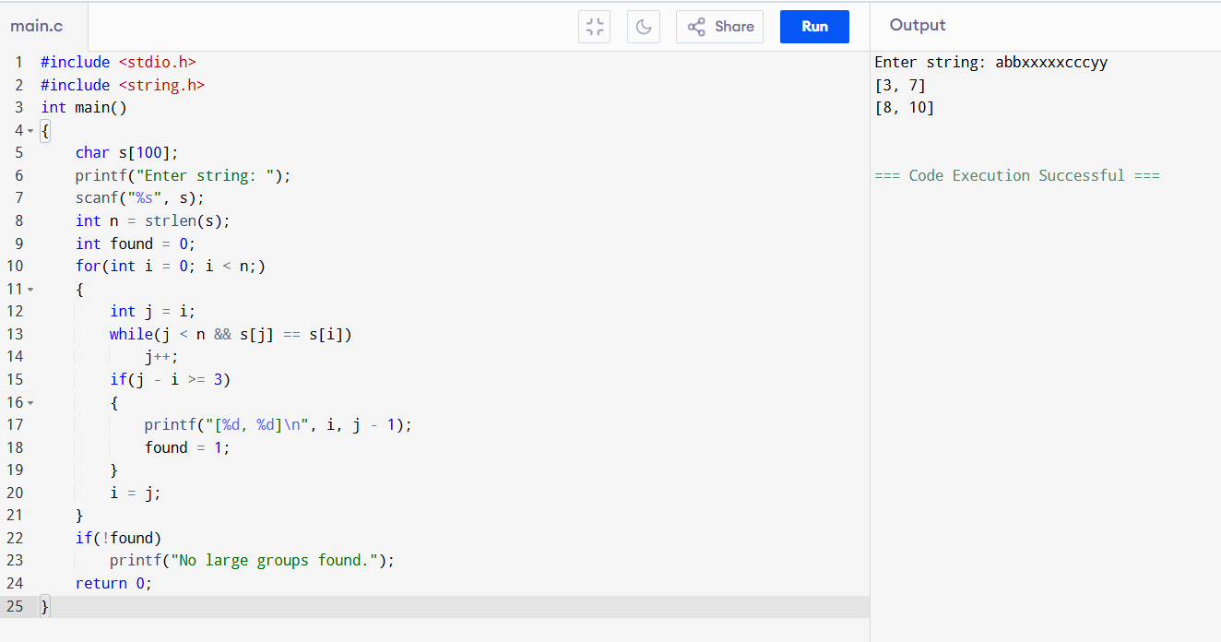
Sample Input
Enter string: abbxxxxzzy
Sample Output
[3, 6]
Time Complexity
O(n)
Space Complexity
O(1)

Result
Thus, the C program successfully identified all large groups in the given string.
16. "The Game of Life, also known simply as Life, is a cellular automaton devised by the British mathematician John Horton Conway in 1970." The board is made up of an m x n grid of cells, where each cell has an initial state: live (represented by a 1) or dead (represented by a 0). Each cell interacts with its eight neighbors (horizontal, vertical, diagonal) using the following four rules. Any live cell with fewer than two live neighbors dies as if caused by under-population. Any live cell with two or three live neighbors lives on to the next generation. Any live cell with more than three live neighbors dies, as if by over-population.
Any dead cell with exactly three live neighbors becomes a live cell, as if by reproduction. The next state is created by applying the above rules simultaneously to every cell in the current state, where births and deaths occur simultaneously. Given the current state of the m x n grid board return the next state.
Example 1:
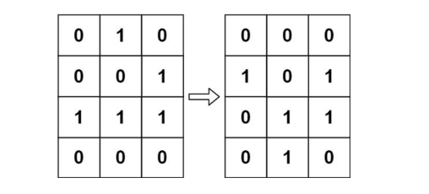
Input: board = [[0,1,0],[0,0,1],[1,1,1],[0,0,0]]
Output: [[0,0,0],[1,0,1],[0,1,1],[0,1,0]]
Example 2:
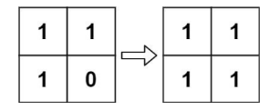
Input: board = [[1,1],[1,0]]
Output: [[1,1],[1,1]]

Aim
To write a C program to generate the next state of Conway's Game of Life based on the given rules.
Algorithm
- Read the number of rows and columns.
- Read the initial board.
- For each cell, count its eight live neighbors.
- Apply the Game of Life rules:
  - Live cell with fewer than 2 neighbors dies.
  - Live cell with 2 or 3 neighbors survives.
  - Live cell with more than 3 neighbors dies.
  - Dead cell with exactly 3 neighbors becomes alive.
- Store the next state in another matrix.
- Print the updated board.
Code:
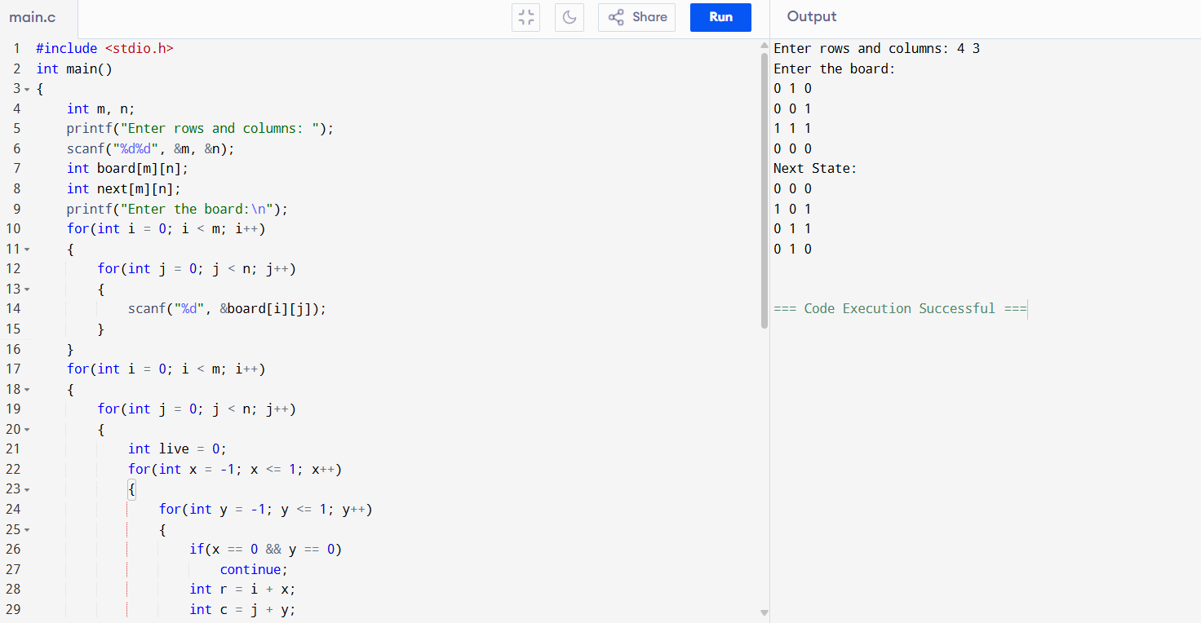
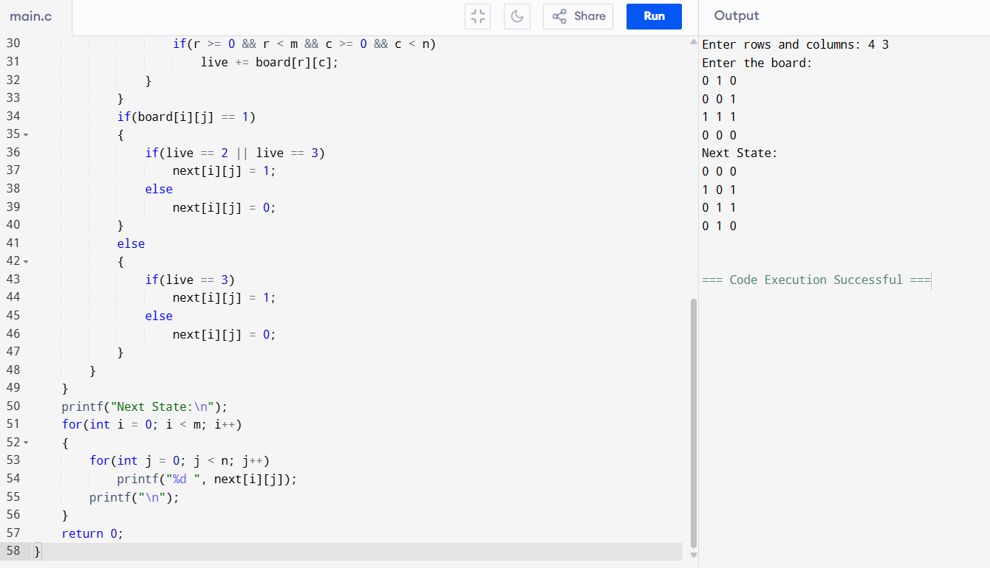

Sample Input
Enter rows and columns:
4 3
Enter the board:
0 1 0
0 0 1
1 1 1
0 0 0
Sample Output
Next State:
0 0 0
1 0 1
0 1 1
0 1 0

Time Complexity
O(m × n)
Space Complexity
O(m × n)

Result
Thus, the C program successfully generated the next state of the Game of Life.

17. We stack glasses in a pyramid, where the first row has 1 glass, the second row has 2 glasses, and so on until the 100th row. Each glass holds one cup of champagne. Then, some champagne is poured into the first glass at the top. When the topmost glass is full, any excess liquid poured will fall equally to the glass immediately to the left and right of it. When those glasses become full, any excess champagne will fall equally to the left and right of those glasses, and so on. (A glass at the bottom row has its excess champagne fall on the floor.) For example, after one cup of champagne is poured, the top most glass is full. After two cups of champagne are poured, the two glasses on the second row are half full. After three cups of champagne are poured, those two cups become full - there are 3 full glassestotal now. After four cups of champagne are poured, the third row has the middle glass half full, and the two outside glasses are a quarter full, as pictured below.
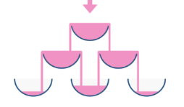
Now after pouring some non-negative integer cups of champagne, return how full the jth glass in the ith row is (both i and j are 0-indexed.)
Example 1:
Input: poured = 1, query_row = 1, query_glass = 1
Output: 0.00000
Explanation: We poured 1 cup of champange to the top glass of the
tower (which is indexed as (0, 0)). There will be no excess liquid so all
the glasses under the top glass will remain empty.
Example 2:
Input: poured = 2, query_row = 1, query_glass = 1
Output: 0.50000
Explanation: We poured 2 cups of champange to the top glass of the
tower (which is indexed as (0, 0)). There is one cup of excess liquid.
The glass indexed as (1, 0) and the glass indexed as (1, 1) will share
the excess liquid equally, and each will get half cup of champange.

Aim
To write a C program to determine the amount of champagne present in a specified glass after pouring a given number of cups into the top glass.
Algorithm
- Read the number of poured cups, query row, and query glass.
- Create a 2D array initialized to zero.
- Pour all champagne into the top glass.
- For each glass, if it overflows (more than 1 cup), distribute the excess equally to the two glasses below.
- Continue until the required row is reached.
- Print the amount in the required glass (maximum value is 1).

Code:
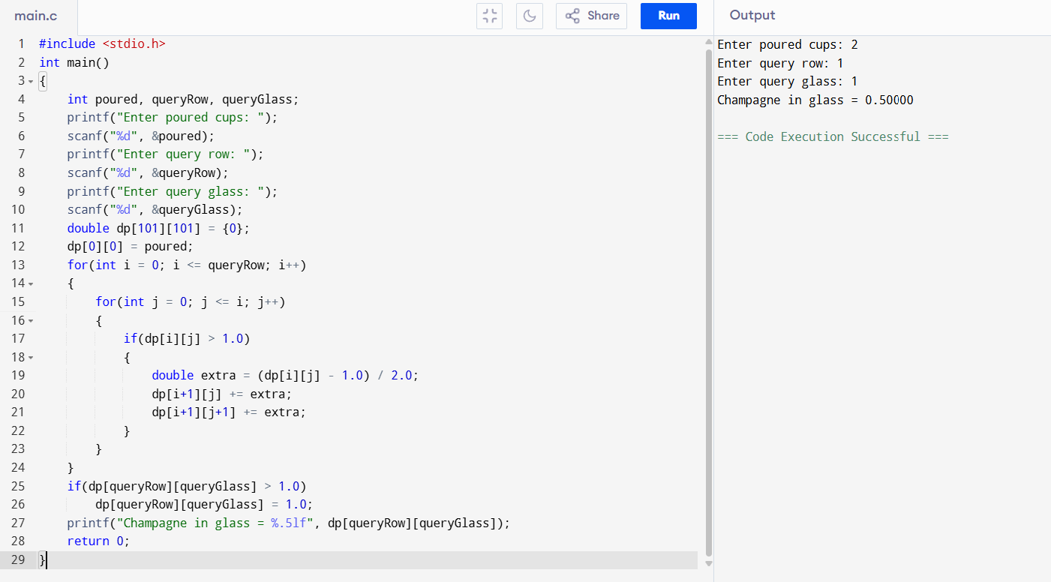
Sample Input
Enter poured cups: 2
Enter query row: 1
Enter query glass: 1
Sample Output
Champagne in glass = 0.50000
Time Complexity
O(n²)
Space Complexity
O(n²)

Result
Thus, the C program successfully determined the amount of champagne present in the specified glass after pouring the given number of cups.

